Battery Tray Sub Assembly
The following are a list of the parts needed for this sub-assembly. Items that need to be 3D printed are highlighted in the column named “3D Printed”.
Name | Qty | 3D Printed?
Battery Flap Cover | 1 | Y
Battery Door Spring | 1 | N
Battery Flap Rod Support | 1 | Y
Battery Latch Thumb Piece L | 1 | Y
Battery Latch Thumb Piece R | 1 | Y
M3x3mm Heat Insert | 8 | N
M3x6mm Hex Cap Screws | 8 | N

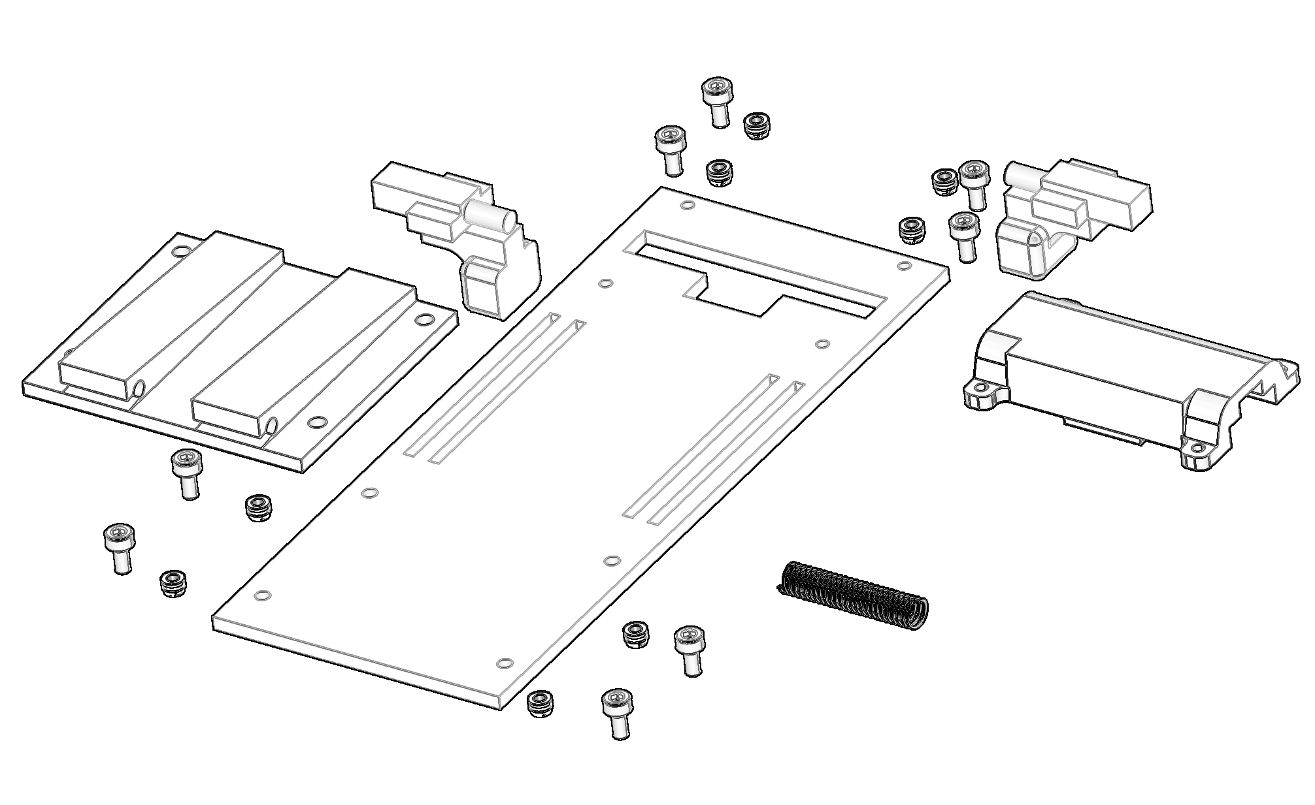

Step 1.
Start by inserting all 8 of the heat inserts into the cover. These go in from the top side down.
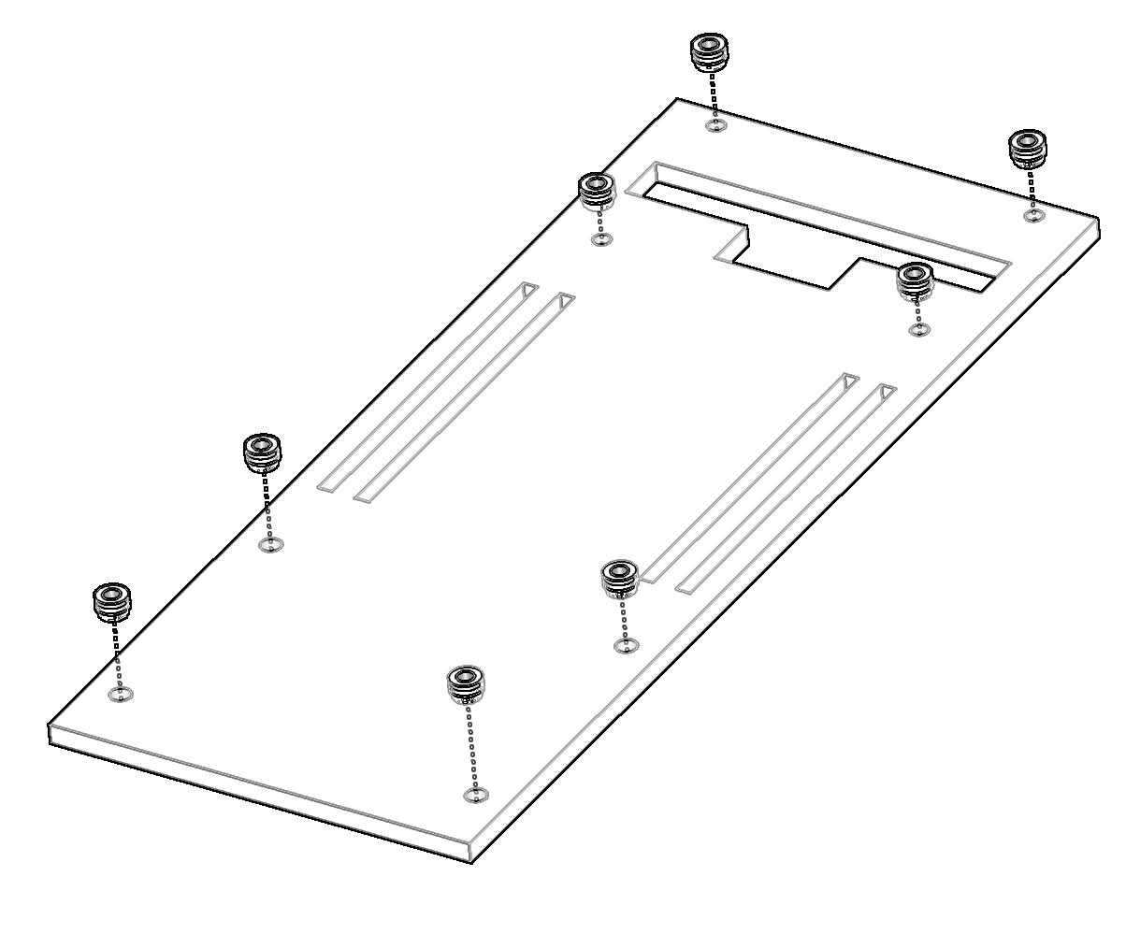

Step 2.
Start by flipping the cover upside down. From the bottom side of the cover angle each thumb piece so they can fit through the larger center opening. Once in far enough, rotate and push each to the outside.
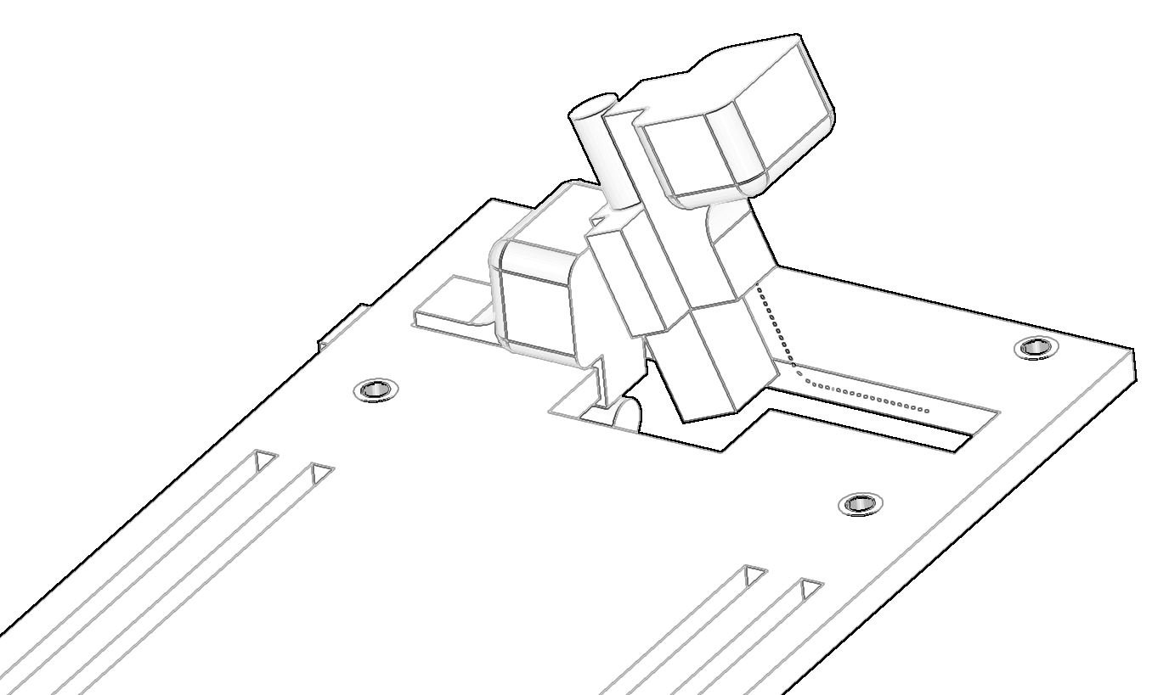

Then hold each thumb piece in place while rotating the cover back over to its original position. The result should look like this and prepare you for spring isertion.
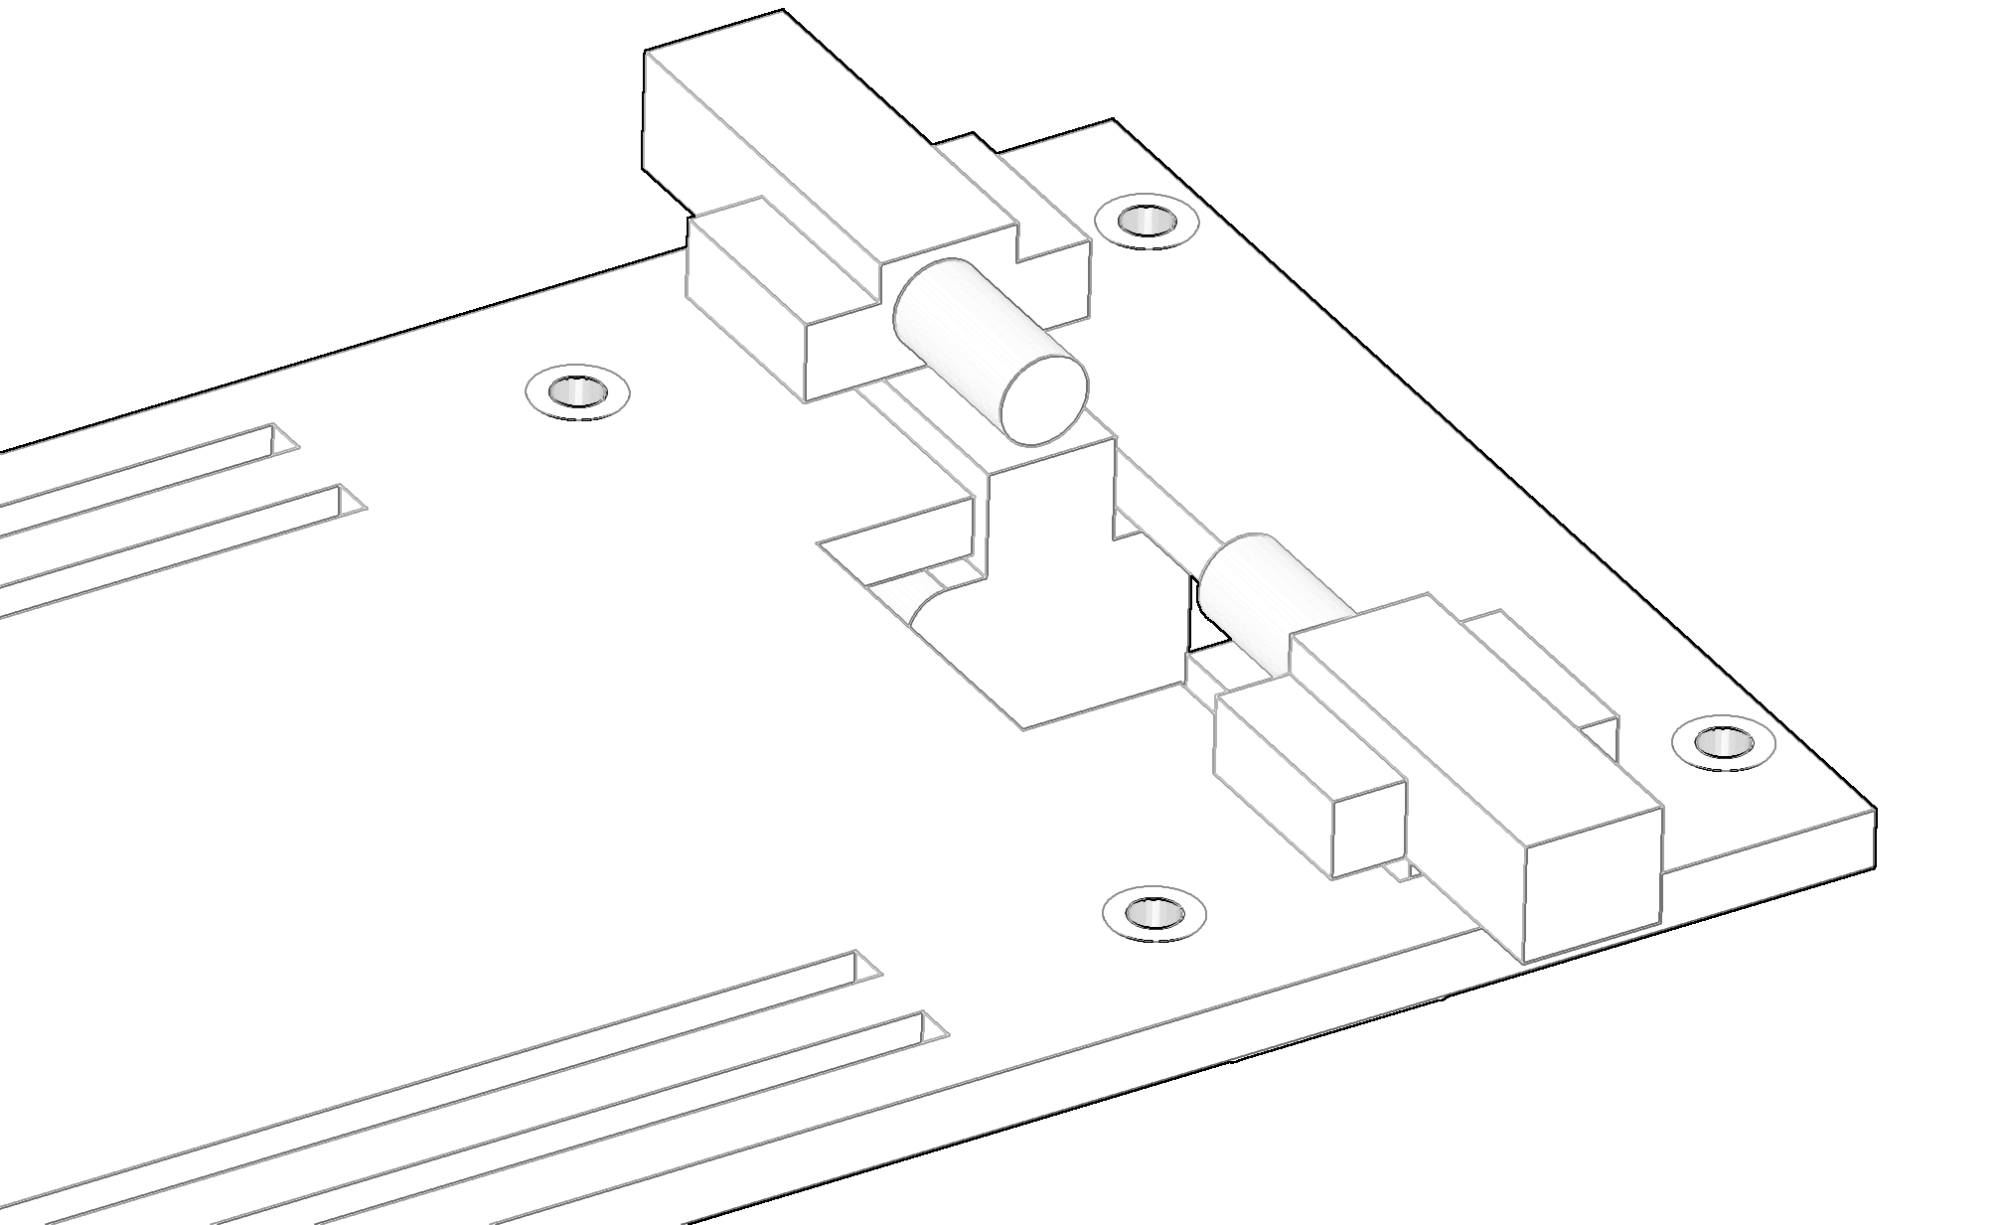

Step 3.
Bend and install the spring in between the two thumb pieces. Once installed it should put strong outward pressure on both thumb pieces. This keeps them engaged with the main body so that the battery door does not open accidentally.
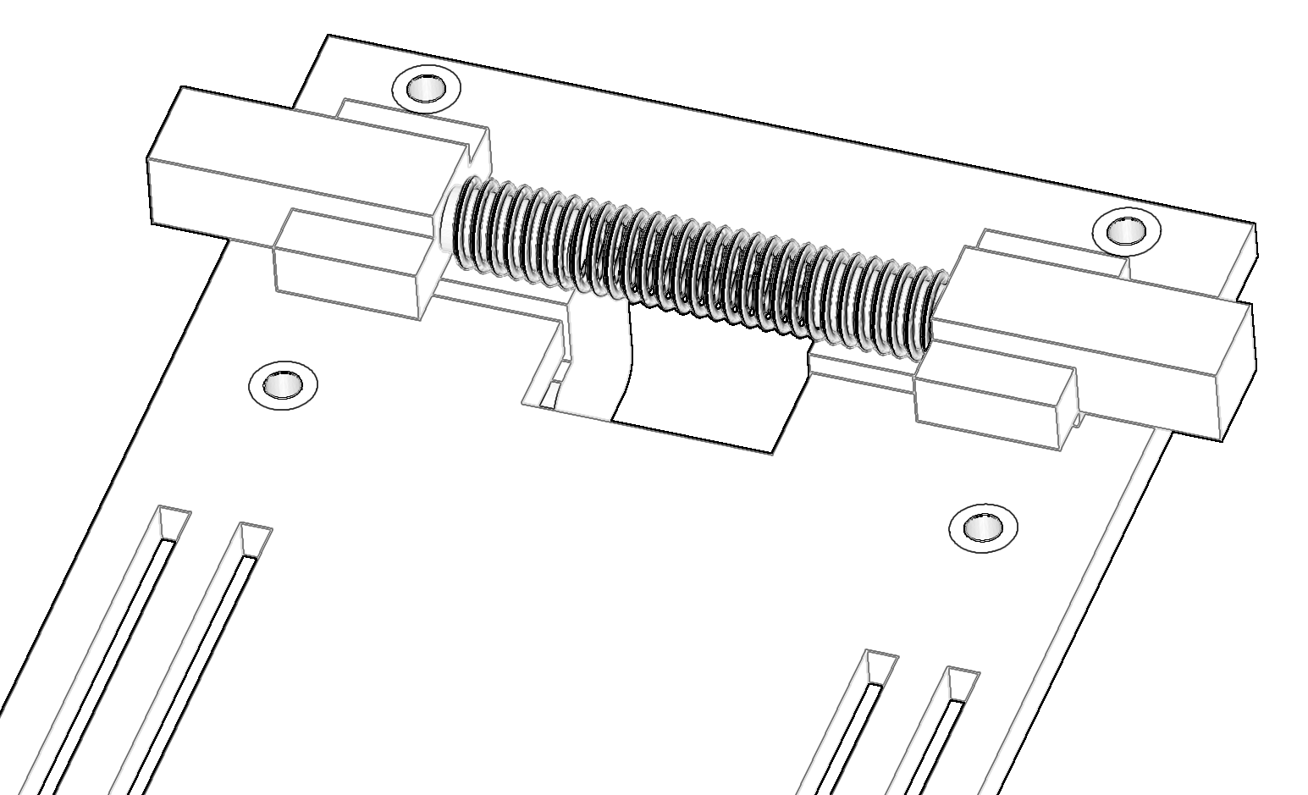

Step 4.
Next, install the spring and latch cover to retain the spring in place during compression and keep items from being pinched. This is done using 4 of the M3x6mm screws threading into the heat inserts installed previously.
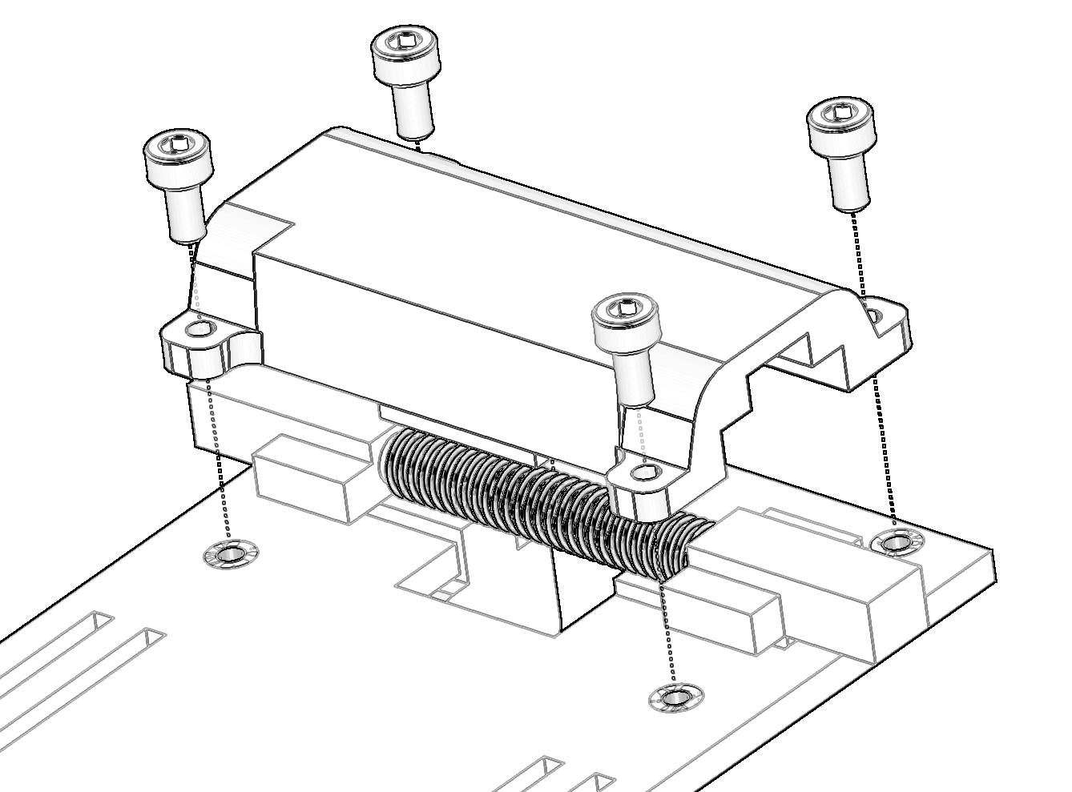

Step 5.
Once completed you can install the battery support piece that provides the pivot joint for the battery door, and provides support to the battery to keep it angled upward. This is attached again utilizing 4 more of the M3x6mm screws threading into the corresponding heat inserts.
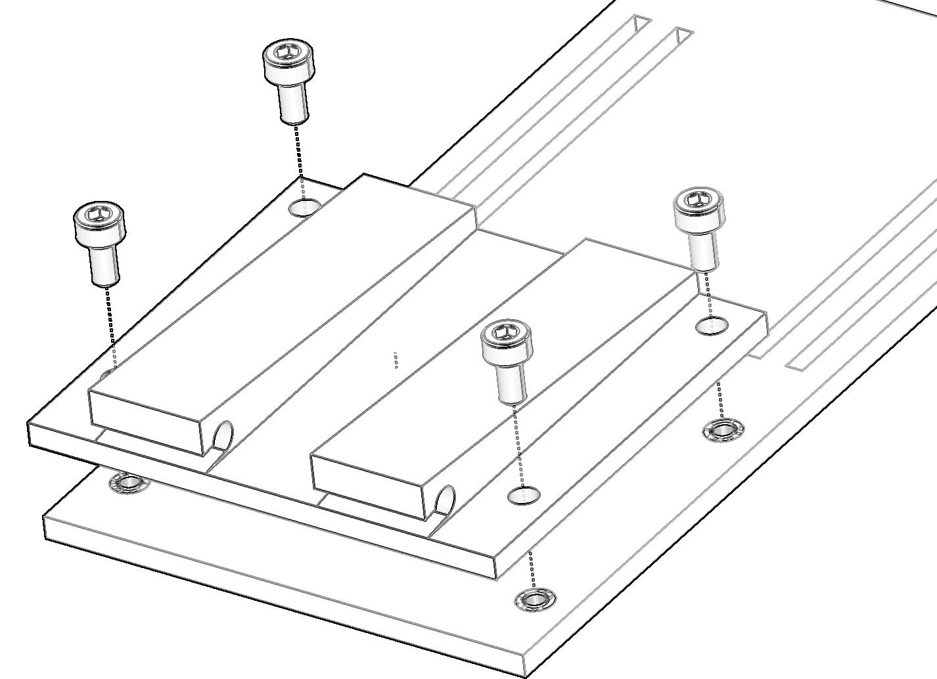

Complete
Congratulations you’ve completed the assembly of the battery tray sub-assembly. Simply ensure the thumb releases compress the spring and move inwards to release the tray. They should move close to one another, but not far enough that the pieces can come out of the cover.
